

E-Health System

Team 2 K16T1



**Architecture and design document**

🗋 Written by Ta Ngoc Thien Phu

🗋 Version 1.2

🗋 For E- Health System

Contents

**Revision history** 2

**List of table** 3

**1.** **Section 1: Document Description** 4

**1.1** **Purpose of document** 4

**2.** **Section 2: Project Overview** 5

**2.1** **Introduction** 5

**2.2** **Scope** 5

**2.3** **Document Object** 5

**3.** **Section 3: Architectural Drivers** 6

**3.1** **Functional requirement** 6

**3.2** **Quality Attributes** 6

**3.3** **Constraints** 6

**4.** **Section 4: System Context** 8

**4.1** **System context** 8

**4.2** **Element catalog** 8

**5.** **Section 5: Decomposition** 9

**5.1** **Physical view** 9

**5.2** **Dynamic view** 10

**5.3** **Stactic view** 35

**6.** **Section 6: Architecture summary (mapping view)** 39

**6.1.** **Mapping Physical and Dynamic View** 39

**6.2.** **Mapping Dynamic View and Static View** 39

**7.** **Section 7: Document Directory** 41

**7.1.** **Document Reference** 41

# **Revision history**

|  |  |  |  |
| --- | --- | --- | --- |
| **Version** | **Updated Date** | **Author** | **Description** |
| 1.0 | 24/06/2013 | Ta Ngoc Thien Phu | Define document |
| 1.1 | 01/07/2013 | Le Ngoc Chau | Update template |
| 1.2 | 07/07/2013 | Le Ngoc Chau | Update Dynamic view |

# **List of table**

*Table 1: Role and responsibilities* 5

*Table 2: Functional requirement* 6

*Table 3: Quality attribute* 6

*Table 4: Technical constraint* 6

*Table 5: Business constraint* 7

*Table 6: Element catalog* 8

*Table 7: Element catalog Layer style* 35

*Table 8: Element catalog decomposition style* 37

*Table 9: Mapping* 40

# **Section 1: Document Description**

## **Purpose of document**

This document gives a high-level architecture of E – Health system.

In this document for this document includes important parts below:

**Part 1:** How to read this document.

**Part 2:** System overview- The summary architectural of project.

**Part 3:** architectural drivers – focus decryption functional requirement, quality attribute and constraint.

**Part 4: s**ystem context – decryption actor impact on the system.

**Part5:** View (important part)

*Physical* – How software and hardware interact with each other.

*Static* – Which and how modules communicated together

*Dynamic* – The interaction between components.

**Part 6:** Architecture summary: decryption reason design system and link to view in design document.

**Part 7:** Document Directory: that includes document Referent and term Description

# **Section 2: Project Overview**

## **Introduction**

The E - Health System is a application executes for manage employee, doctors, nurses, cashiers… and manage all departments of hospital. Computers will connect to each other by LAN

## **Scope**

This project include 2 module:

* System management
* Cashier management

Have 4 quality attributes

* Performance
* Security
* Modifiability
* Usability

## **Document Object**

|  |  |  |
| --- | --- | --- |
| **No** | **Role** | **Responsibility** |
| 1 | Team leader | Review |
| 2 | Software Architecture team | Develop software architecture document |
| 3 | Detail design team | Base on this document, develop software detail design document |

*Table 1: Role and responsibilities*

# **Section 3: Architectural Drivers**

## **Functional requirement**

|  |  |
| --- | --- |
| **Module** | **Feature** |
| System Management | User Management |
| Authorization Management |
| Catalog Management |
| Cashier Management | Enter Data |
| Cashier |

*Table 2: Functional requirement*

## **Quality Attributes**

|  |  |  |
| --- | --- | --- |
| **ID** | **Type** | **Description** |
| 1 | Security | Security is the capability of a system to prevent malicious or accidental actions outside of the designed usage, and to prevent disclosure or loss of information. A secure system aims to protect assets and prevent unauthorized modification of information |
| 2 | Performance | Performance is an indication of the responsiveness of a system to execute any action within a given time interval. It can be measured in terms of latency or throughput. Latency is the time taken to respond to any event. Throughput is the number of events that take place within a given amount of time.. |
| 3 | Usability | Usability defines how well the application meets the requirements of the user and consumer by being intuitive, easy to localize and globalize, providing good access for disabled users, and resulting in a good overall user experience. |

*Table 3: Quality attribute*

## **Constraints**

1. Technical constraint

|  |
| --- |
| * Operation system is Window 7 |
| * Database is SQL server. |
| * Language is C#. |

*Table 4: Technical constraint*

1. Business constraint

|  |  |
| --- | --- |
| **ID** | **Description** |
| 1 | Since no bar code reader, user can enter these codes by using computer keyboard |
| 2 | Each bill have a private barcode |
| 3 | Bill code have 15 character and it is showed follow form yymmdd_xxxxx_AA (note : yymmdd = year year month month day day , xxxx is a integer and it is automatic, AA is a symbol of service ) |
| 4 | The computer of enter data employee is connected to cashier in Cashier Table without connected to cashier of other Cashier Table and opposite |
| 5 | Enter data employee must print three bill (each bill have a color ) |
| 6 | After patient payment, cashier must validate on system and give bill 1,2 for patient and keep bill 3 |

*Table 5: Business constraint*

# **Section 4: System Context**

## **System context**



## **Element catalog**

|  |  |  |
| --- | --- | --- |
| **ID** | **Implement** | **Responsibility** |
| 1 | E-Health System | E-Health System has responsibility to manage employee in hospital and manage cashier |
| 2 | Other System | Other System include Module Patient Management and Patient Report Management have responsibility manage patient and report of patient, provide data about patient to support E-Health System. |
| 3 | Administrator | Administrator has responsibility to handle technical of system |
| 4 | Cashier | Cashier who use system to manage bill |

*Table 6: Element catalog*

# **Section 5: Decomposition**

## **Physical view**





## **Dynamic view**

1. Dynamic level 1



* Manage catalog



* Manage report



* Manage cashier



1. Dynamic level 2
   1. Category



* 1. Cashier



* 1. Report



1. Dynamic level 3
   1. User



* + 1. Create user



* + 1. Edit user



* 1. User group



* + 1. Create user group



* + 1. Edit user group



* + 1. Set Authorization



* 1. Configuration



* + 1. Log in



* + 1. Log out



* + 1. Configure



* + 1. Change password



* 1. Typist



* + 1. Create bill



* 1. Payment



* + 1. Confirm payment



* + 1. Search bill



* 1. Report about bill that is created



* + 1. Print report



* 1. Report about bill that is confirmed



* + 1. Print report



* 1. List Payment by Group



* + 1. Print report



* 1. Revenue by Group



* + 1. Print report



## **Stactic view**

1. Layer style



|  |  |  |
| --- | --- | --- |
| **Element catalog** | | |
| **ID** | **Element** | **Description** |
| 1 | GUI | This module represents user interface of the system. |
| 2 | Business | This module represents controller of the system. It will process requests from client send to server. It belongs to Business Layer |
| 3 | Data Object | This module represents data object of the system contain data flow between the layers together |
| 4 | Data Access | This module will receive request to DB from Business layer and create connections, execute DB transactions |
| 5 |  | It's dependency that means each component of layer A can use all of components of layer B. |

*Table 7: Element catalog Layer style*

1. Decomposition style



|  |  |  |
| --- | --- | --- |
| **Element catalog** | | |
| **ID** | **Element** | **Description** |
| 1 | GUI | This module represents user interface of the system. |
| 2 | Business | This module represents controller of the system. It will process requests from client send to server. It belongs to Business Layer |
| 3 | Data Object | This module represents data object of the system contain data flow between the layers together |
| 4 | Data Access | This module will receive request to DB from Business layer and create connections, execute DB transactions |
| 5 |  | It's dependency that means each component of layer A can use all of components of layer B. |
| 6 | User Management | This is user management interface, administrator can handle application relate to users information on this interface |
| 7 | Catalog Management | This is feature that manage catalogs of system, catalogs include : service catalog, service type catalog, department catalog, department type catalog, city catalog, district catalog. |
| 8 | Authorization Management | This is an interface that administrator can set authorization for users |
| 9 | Typist | Allow to typist enter data |
| 10 | Cashier | Support for cashier who can collect money of patient |
| 11 | User processing | The process relate to processing user information |
| 12 | Catalog processing | The process which manage catalogs such as service catalog, service type catalog, department catalog, department type catalog, city catalog, district catalog. |
| 13 | Authorization processing | The process which administrator is allowed to set authorization for user |
| 14 | Typist processing | The process that processing information on bill |
| 15 | Cashier processing | The process support for cashier about bill payment |
| 16 | Access User | Connect to user info from data object |
| 17 | Access Authorization | Connect to authorization info from data object |
| 18 | Access Bill | Connect to bill info from data object |
| 19 | Access Detail Bill | Connect to detail bill info from data object |
| 20 | Access District | Connect to district info from data object |
| 21 | Access City | Connect to city info from data object |
| 22 | Access Department | Connect to department info from data object |
| 23 | Access Department Type | Connect to department type info from data object |
| 24 | Access Service | Connect to service info from data object |
| 25 | Access Service Type | Connect to service type info from data object |
| 26 | User Info | Information relate to user |
| 27 | Authorization Info | Information relate to authorization |
| 28 | Bill Info | Information relate to bill |
| 29 | Detail Bill Info | Detail Information relate to bill |
| 30 | District Info | Information relate to district |
| 31 | City Info | Information relate to city |
| 32 | Department Info | Information relate to department |
| 33 | Department Type Info | Information relate to department type |
| 34 | Service Info | Information relate to service |
| 35 | Service Type Info | Information relate to service type |

*Table 8: Element catalog decomposition style*

1. Data model style





# **Section 6: Architecture summary (mapping view)**

## **Mapping Physical and Dynamic View**

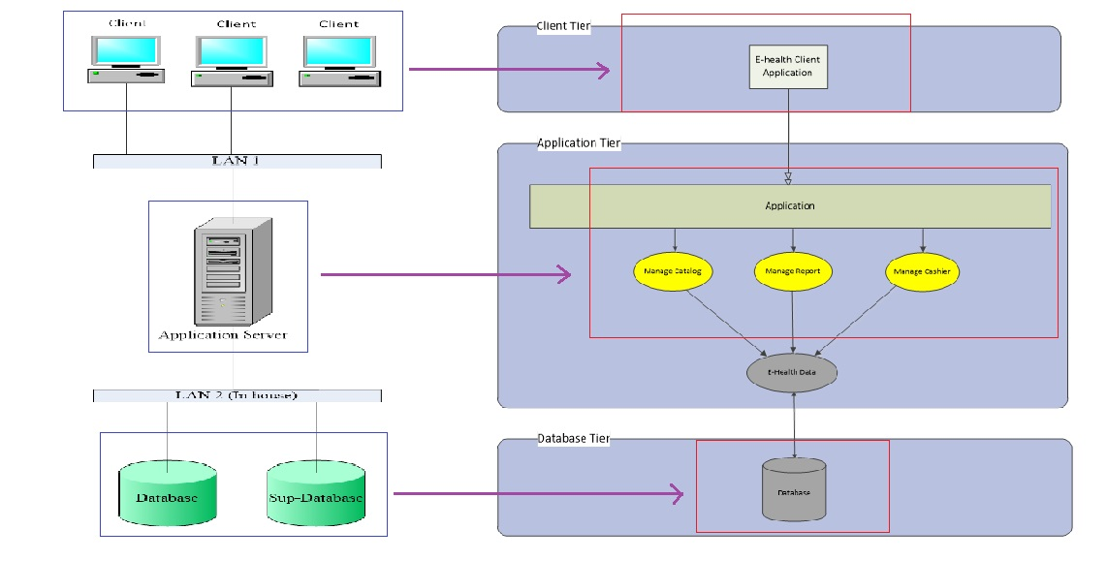

## **Mapping Dynamic View and Static View**

|  |  |  |  |  |  |  |  |  |  |
| --- | --- | --- | --- | --- | --- | --- | --- | --- | --- |
| Process/ Module | User | User Group | Configure | Typist | Cashier | Bill is created | Bill of payment | Payment Group List | Group Revenue |
| Create User | v |  |  |  |  |  |  |  |  |
| Edit User | v |  |  |  |  |  |  |  |  |
| Search User | v | v |  |  |  |  |  |  |  |
| Create User Group |  | v |  |  |  |  |  |  |  |
| Edit User Group |  | v |  |  |  |  |  |  |  |
| Set authorization |  | v |  |  |  |  |  |  |  |
| Search User Group |  | v |  |  |  |  |  |  |  |
| Log-in |  |  | v |  |  |  |  |  |  |
| Log- out |  |  | v |  |  |  |  |  |  |
| Change password |  |  | v |  |  |  |  |  |  |
| Configure |  |  | v |  |  |  |  |  |  |
| Create Bill |  |  |  | v |  |  |  |  |  |
| Print Bill |  |  |  | v |  |  |  |  |  |
| Search Bill |  |  |  |  | v |  |  |  |  |
| Confirm Payment |  |  |  |  | v |  |  |  |  |
| Print report Group revenue |  |  |  |  |  |  |  |  | v |
| Statistic Group revenue |  |  |  |  |  |  |  |  | v |
| Print report Payment Group List |  |  |  |  |  |  |  | v |  |
| Statistic Payment Group List |  |  |  |  |  |  |  | v |  |
| Print report Bill of payment |  |  |  |  |  |  | v |  |  |
| Statistic Bill of payment |  |  |  |  |  |  | v |  |  |
| Print report Bill is created |  |  |  |  |  | v |  |  |  |
| Statistic Bill is created |  |  |  |  |  | v |  |  |  |

*Table 9: Mapping*

# **Section 7: Document Directory**

## **Document Reference**

Documenting Software Architectures 2010 - Paul Clement, Len Bass

Software architecture in Practice – Len Bass, Paul Clement

Documenting Software Architectures – E- Health system K14T

🙞☺🙜